**Experiment 31**

**AIM :**

To design DFA transition diagram of creating string abbaababc in automata.

**Design and output:**

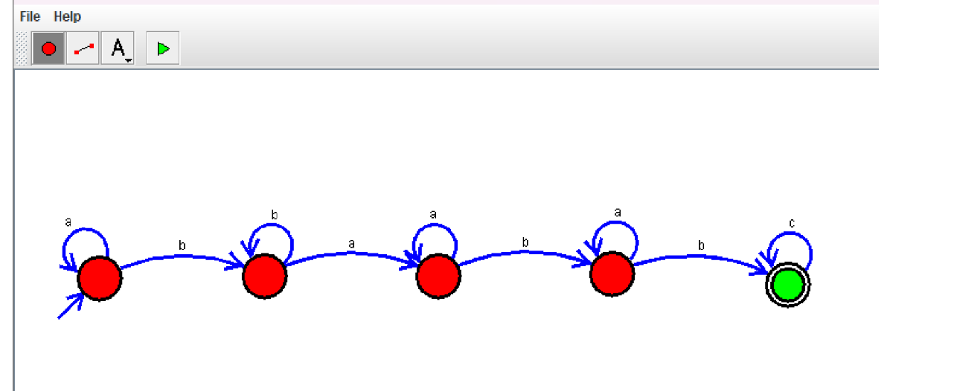

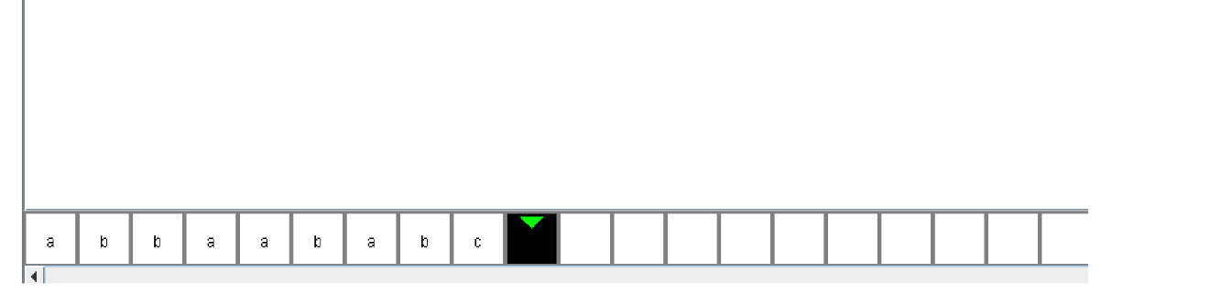

**Result:** Thus designing DFA transition diagram of creating string **abbaababc** is done and verified by giving sample inputs.